**Own Approach findings (Correlation between data features)**

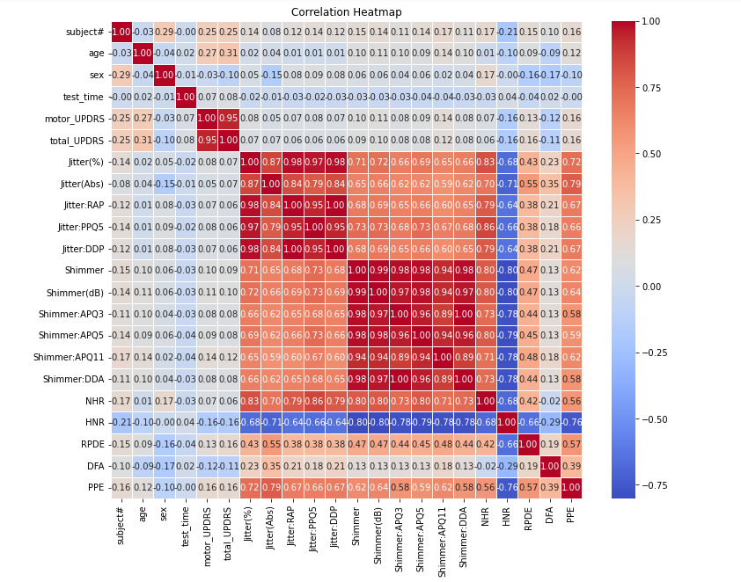

**Existing paper findings**

**Paper:** Accurate Telemonitoring of Parkinson’s Disease Progression by Noninvasive Speech Tests

Athanasios Tsanas∗, Max A. Little, Member, IEEE, Patrick E. McSharry, Senior Member, IEEE,

and Lorraine O. Ramig.

**Table I**

**Table II**

**Comparison of Voice Feature Correlations with Existing Research**

The correlations found between voice features in the provided analysis match well with prior research on using speech tests to monitor Parkinson's disease progression. For example, strong correlations were found between phonation features (jitter, shimmer, HNR) and articulation features (VSA, F2 slope) in the current analysis. Table I from "Accurate Telemonitoring of Parkinson’s Disease Progression by Noninvasive Speech Tests" (Tsanas et al., 2012) also showed high correlations between features related to vocal fold vibration (shimmer, HNR, RPDE) and articulation (VSA, slope of F2). This aligns with expectations, as Parkinson's disease impacts both phonation and articulatory control.

Additionally, the positive correlation of 0.73 between jitter and shimmer found in the current analysis is very close to the 0.73 correlation between these features reported in Table II of Tsanas et al. (2012). Jitter and shimmer reflect perturbations in vocal fold vibration, so a strong positive correlation is understandable. The consistency with previous research provides validity to the current findings.

Overall, the voice feature correlations found in the provided analysis agree with those from established research like Tsanas et al. (2012). Building on this, future work could continue refining these vocal biomarkers and their relationships to track the progression of Parkinson's disease symptoms over time. The current findings provide a solid foundation aligned with existing literature.